# REPORTS

## STEPS :

1. Open Tableau 🡪 Connect to MySql 🡪 Localhost with username: “etl_user” and password: “password”.
2. Connect to Database 🡪 Datamart_db 🡪 Fact_admission.

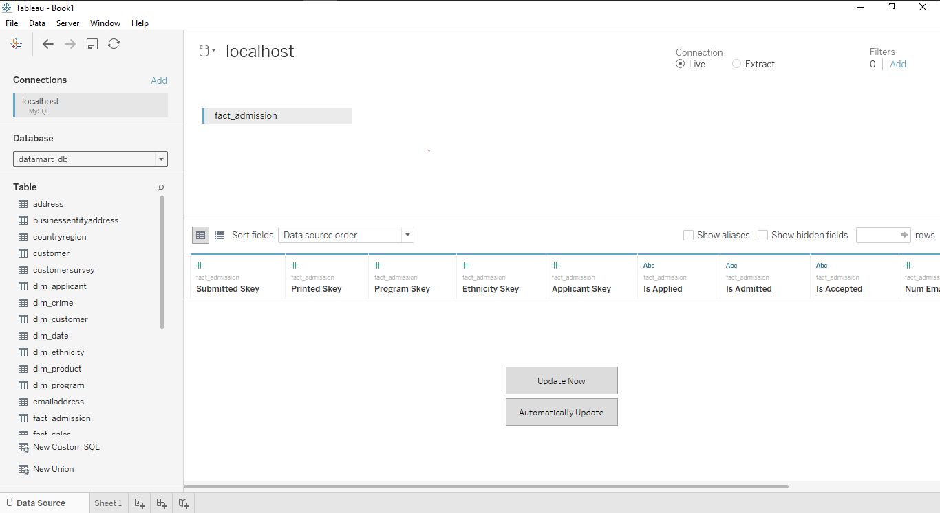

1. Connect Dim_date , Dim_applicant, Dim_ethnicity, Dim_program to Fact_admission as below.

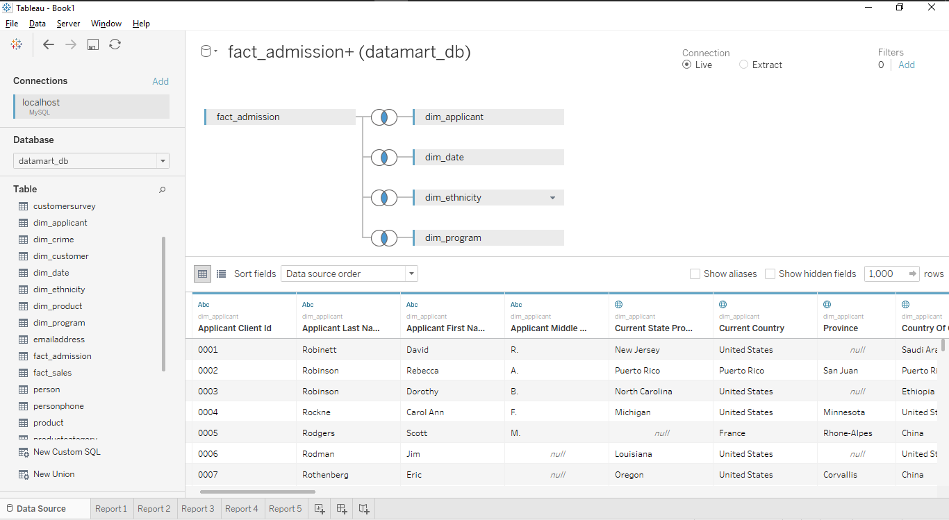

1. Open Sheet 1 and rename to Report 1.
2. Change the Datatype of Dimensions Is Applied, Is Admitted, Is Accepted from String to Number by right clicking 🡪 change Data Type 🡪 Number(Decimal).

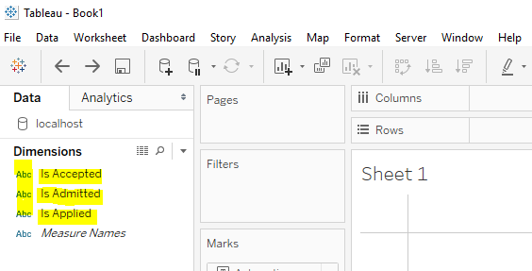

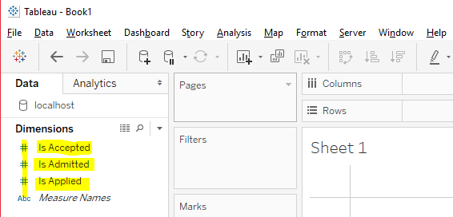

1. Analysis 🡪 Create Calculated field.
2. Give name as Selectivity and the Calculation as “SUM([Is Admitted])/ SUM([Is Applied])”. To get the report in percentage, we have multiplied by 100.

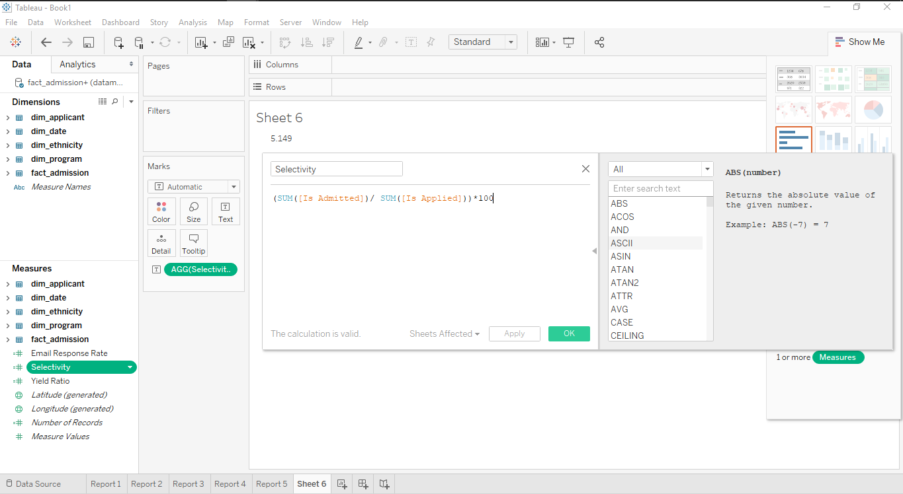

1. Likewise, Analysis 🡪 Create Calculated field.
2. Give name as Yield Ratio and the calculation as “SUM([Is Accepted])/ SUM([Is Admitted])”.

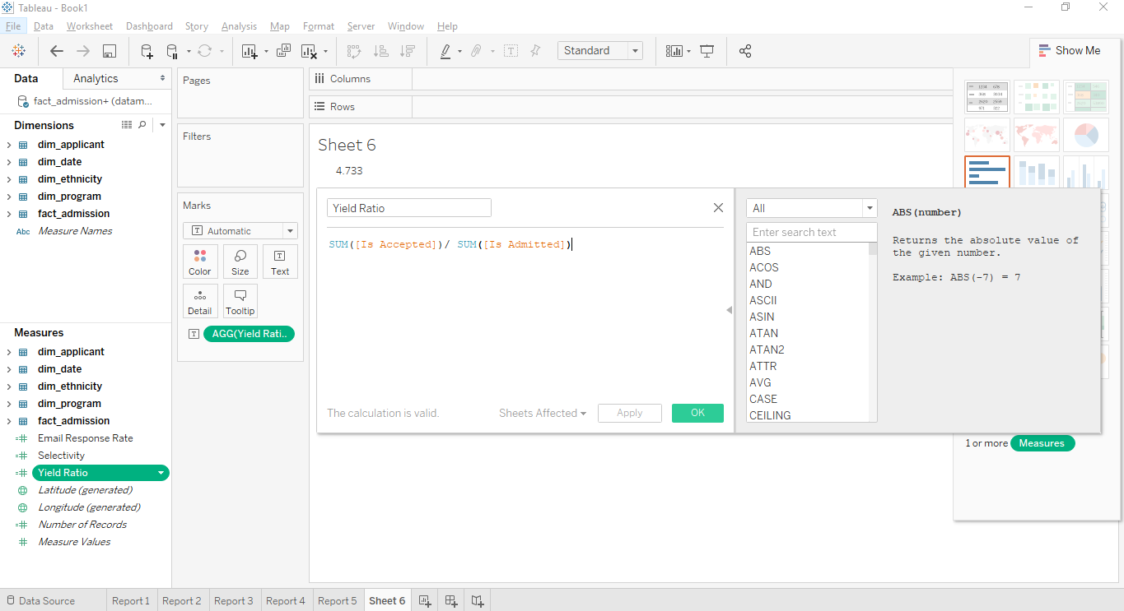

1. Likewise, Analysis 🡪 Create Calculated field.
2. Give name as Email Response Rate and the calculation as “SUM([Num Email By Sch])/SUM([Num Email By App])”.
3. Each Dimensions and Measures are dragged and dropped on each tab to generate new reports accordingly.

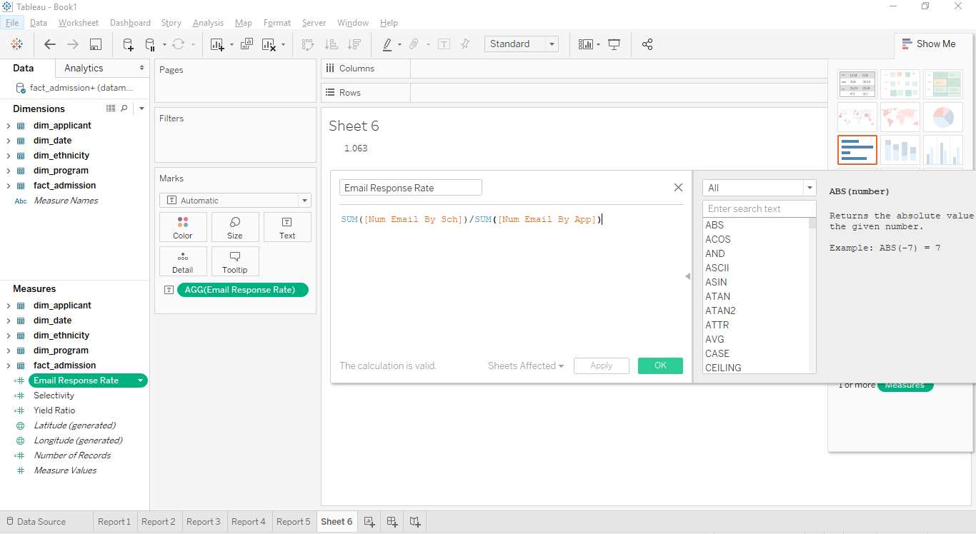

## REPORT RESULTS:

**REPORT 1:**

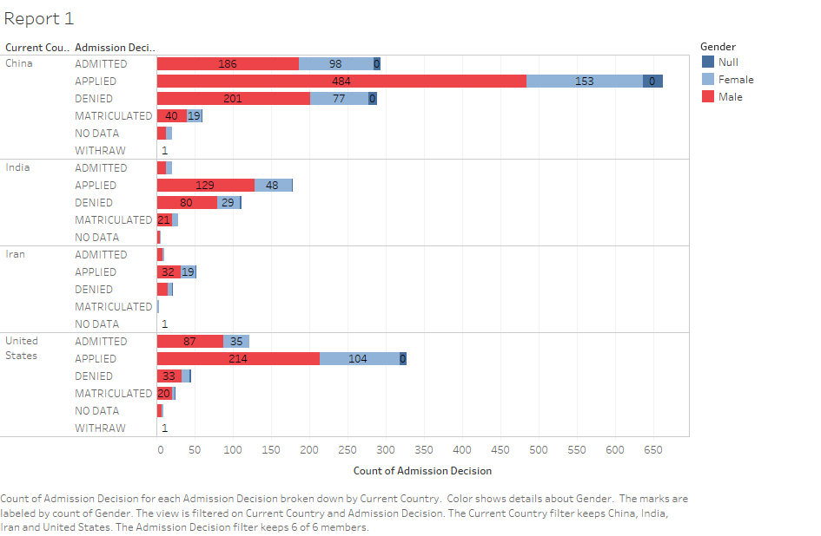

**REPORT 2:**

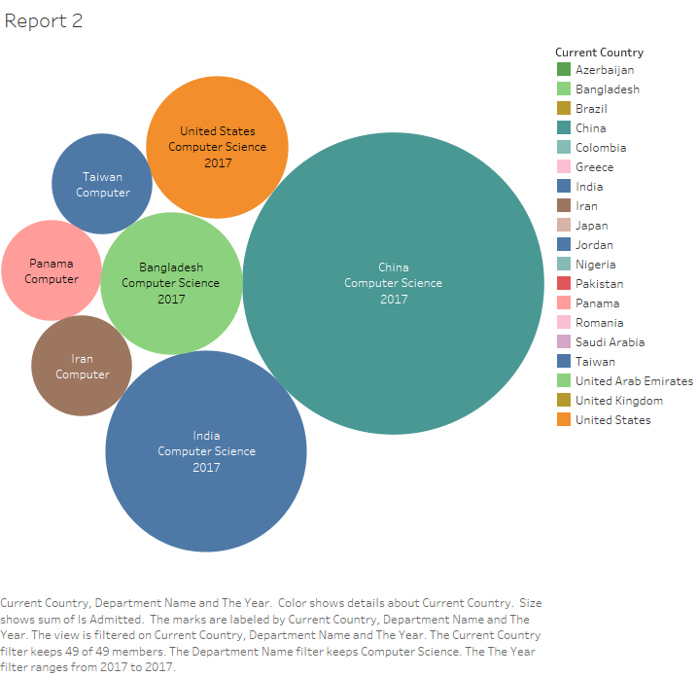

**REPORT 3:**

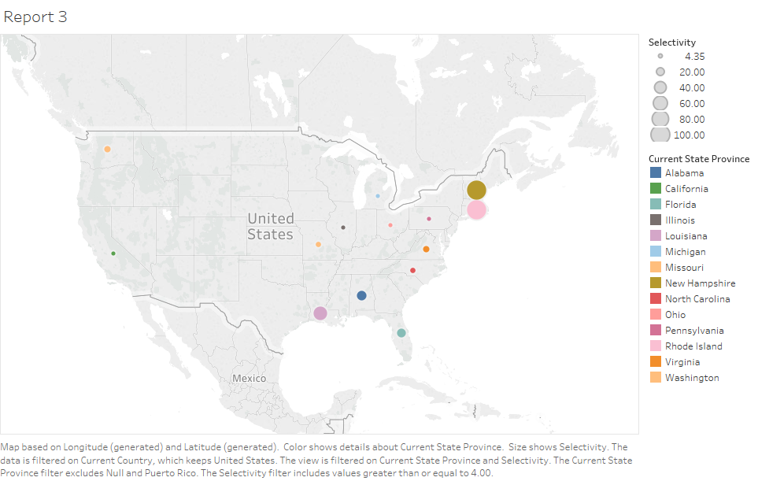

**REPORT 4:**

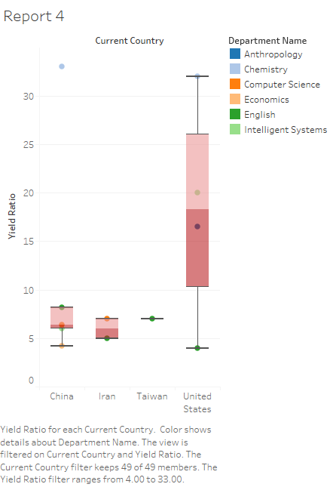

**REPORT 5:**

